Efficiency and Power Homework

1. Curious George (m = 12.5 kg) is running to see the man in the yellow suit. He starts from rest and reaches a top speed of 5.3 m/s. If his body has an efficiency of 85% how much energy did Curious George actually use?
2. A high rise window washer with a mass of 60 kg is on a platform that has a mass of 220 kg. An electric motor does 1.8 x 103 J of work. The electrical energy used by the motor is 1.85 x 105 J.
   1. What is the efficiency of the motor?
   2. How high was the window washing platform lifted?
3. Curious George is watching two piano movers move a 350kg piano up a ramp that is 3m long to a truck that is 80 cm high. If the piano movers exert a force of 1500 N
   1. Find the work done in moving the piano up the ramp
   2. Find the piano’s gravitational potential energy while it is on the truck relative to the ground
   3. Find the efficiency of the ramp
   4. Where does the rest of the energy go?
4. A car exerts a force of 5450 N in order to accelerate over a distance of 123 m in 7.65 s. Calculate the power of the car in watts, and kilowatts. How many horsepower does the car have (1 horsepower = 745 watt)
5. A student (mass = 45 kg) climbs 8 m up a rope at a constant speed of 0.8 m/s
   1. Determine the time it takes the student to climb the rope
   2. Determine the change in the student’s gravitational energy in climbing the rope (the Eg at the top and bottom of the rope relative to the ground)
   3. Determine the power
   4. Why do you not need to find the time in order to find the power?
6. A 65 kg man can climb the stairs in 32 seconds. The change in height is 3.4 m
   1. Find gravitational energy at the top of the stairs relative to the bottom of the stairs
   2. Find the power for the climb
   3. 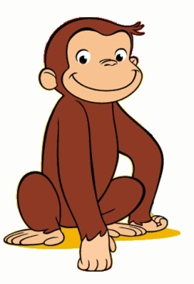If a lighter person climbs the stairs in the same amount of time would the power be higher or lower

Answers

1. 207 J
2. 97%, 0.66 m
3. 4500 J, 2744 J, 61%
4. 8.8 x 104 W, 88 kW, 118 hp
5. 10s, 3528 J, 352.8 W
6. 2166J, 68 W